- We've cut our UK GDP growth forecasts for the rest of 2025 and 2026 in response to the recent US tariff announcements. We now expect growth of 1% this year and 0.9% in 2026.
- We expect US demand for UK goods will drop sharply in response to the increase in relative costs for UK-produced products and the large real income shock that US consumers will suffer. Global demand will also be softer. Our new forecast for UK non-fuel goods exports at the end of 2026 is more than 5% lower than our March projection.
- A prolonged period of trade policy uncertainty will also doubtless weigh on business sentiment at a time when profitability is already under severe pressure.
- We've nudged down our inflation forecast due to lower oil and gas prices and a stronger pound, but the degree of uncertainty is high. Some imported goods could become cheaper as firms target non-US markets; conversely, supply chain disruption could stoke inflationary pressures.
- We're sticking with our call that the Bank of England will cut interest rates by another 75bps this year, with Bank Rate ending 2025 at 3.75%. The tariff increases are a demand shock to the UK economy, calling for looser policy. But we think concerns about the weakness of supply could encourage the Monetary Policy Committee to adopt a more cautious approach.
The flurry of tariff announcements by the US government over recent weeks have impacted on our UK and global forecasts, published this week. Here, we explain the changes for the UK.
We now forecast UK GDP growth of 1% in 2025 and 0.9% in 2026, compared with 1% and 1.5% last month. That we've not cut our forecast for the calendar year average growth rate for this year is entirely due favourable historical data revisions and a much stronger-than-expected Q1. We now expect softer quarterly growth for the remainder of this year and 2026, although the UK should manage to avoid a recession (Chart 1).
Chart 1: We expect much weaker GDP growth in the UK over the next couple of years
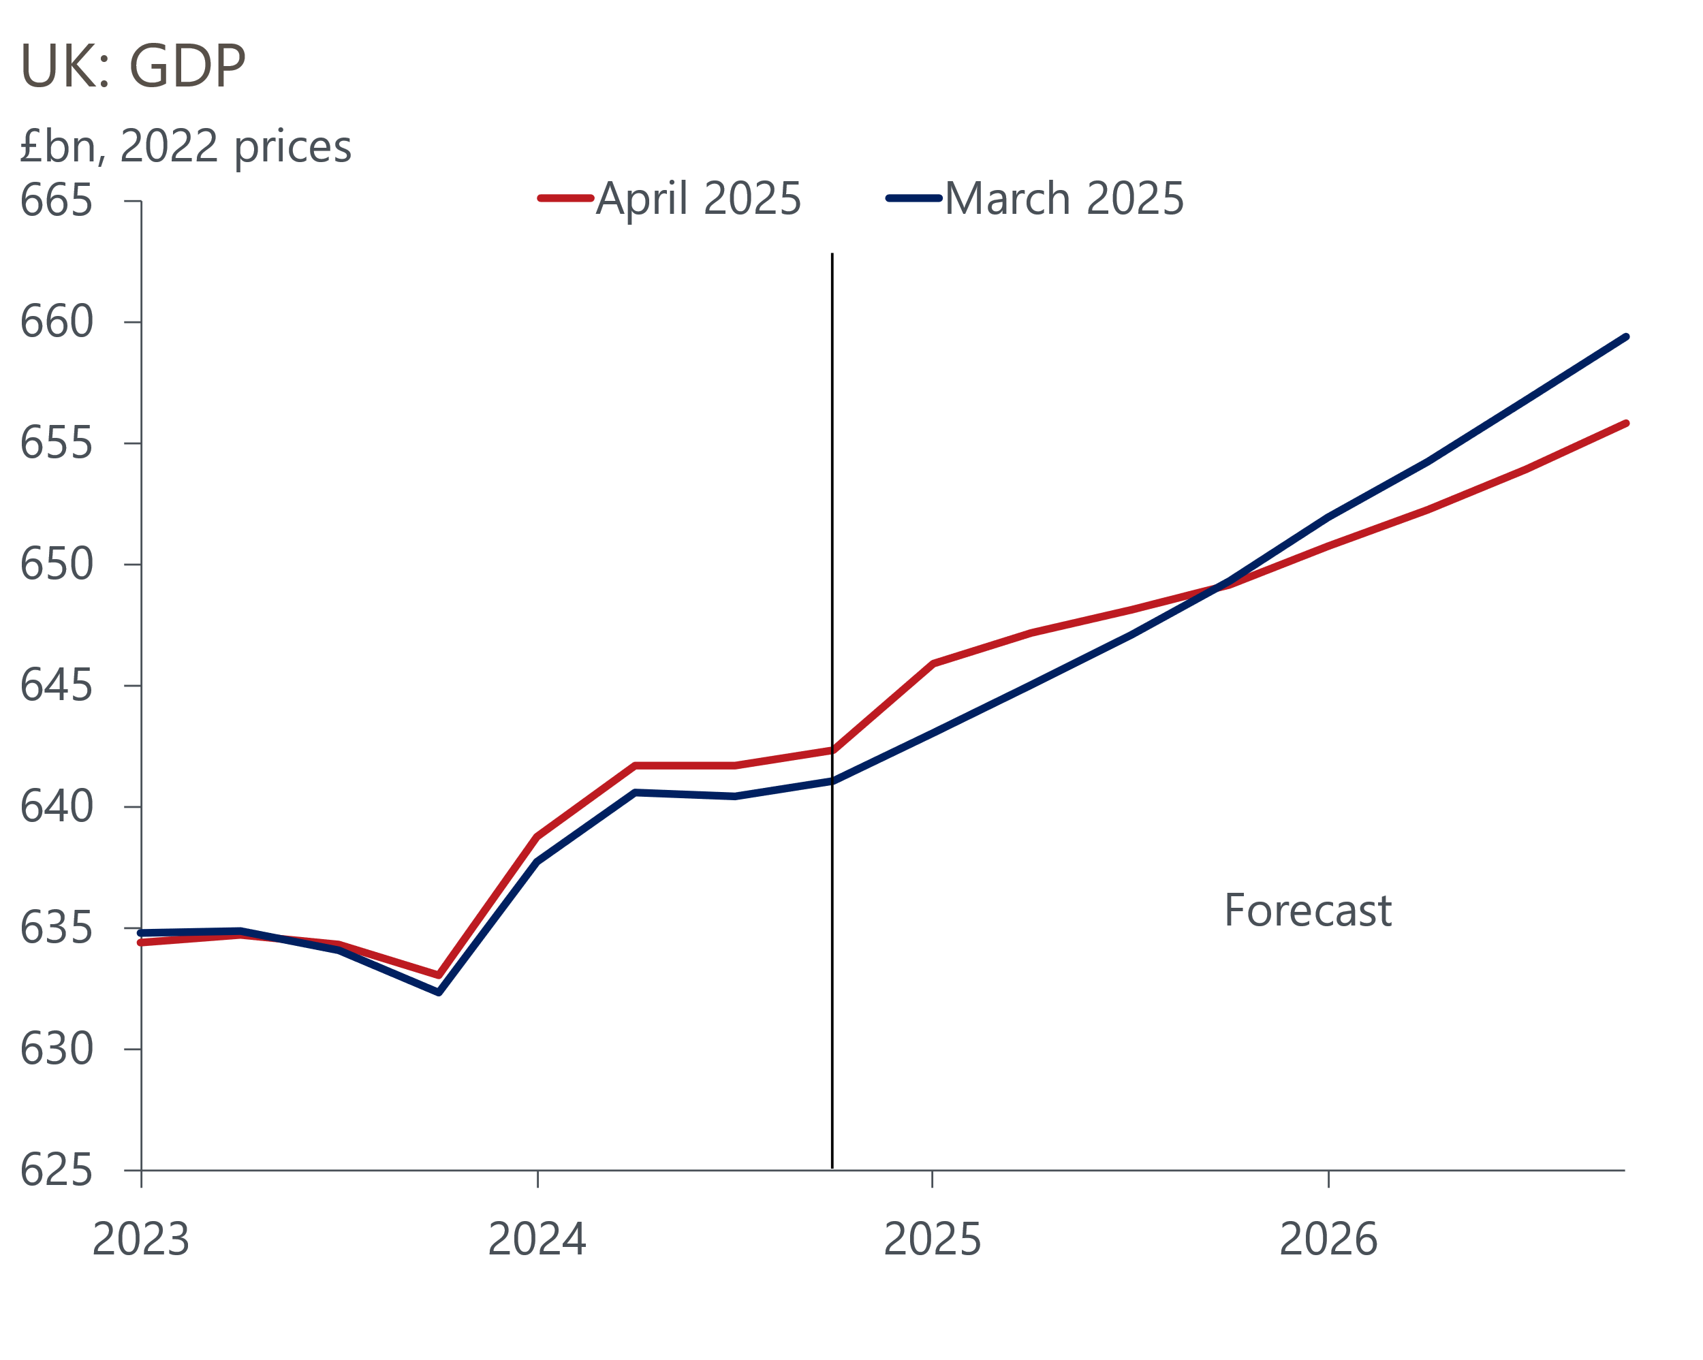
Sources: Oxford Economics, Haver Analytics

The hit to our UK GDP forecast comes from three main sources
The first source of drag is the direct impact of tariffs on US demand for UK exports. Office for National Statistics data suggests goods exports to the US account for 7% of total UK exports. Around two-thirds of UK exports to the US are subject to the 10% minimum tariff increase announced on April 2 (Chart 2). Just over a tenth of exports, most of which are cars or car parts, are subject to other tariffs that have been announced separately. The remainder, including pharmaceuticals, are currently exempt from the minimum tariff increase, but could still face sector-specific tariffs later. We calculate that the effective tariff applied to US imports from the UK has risen to 12.1% from 1.3%, and this increase in costs is likely to significantly weaken US demand for UK goods.
Chart 2: The US is an important destination for UK goods exports
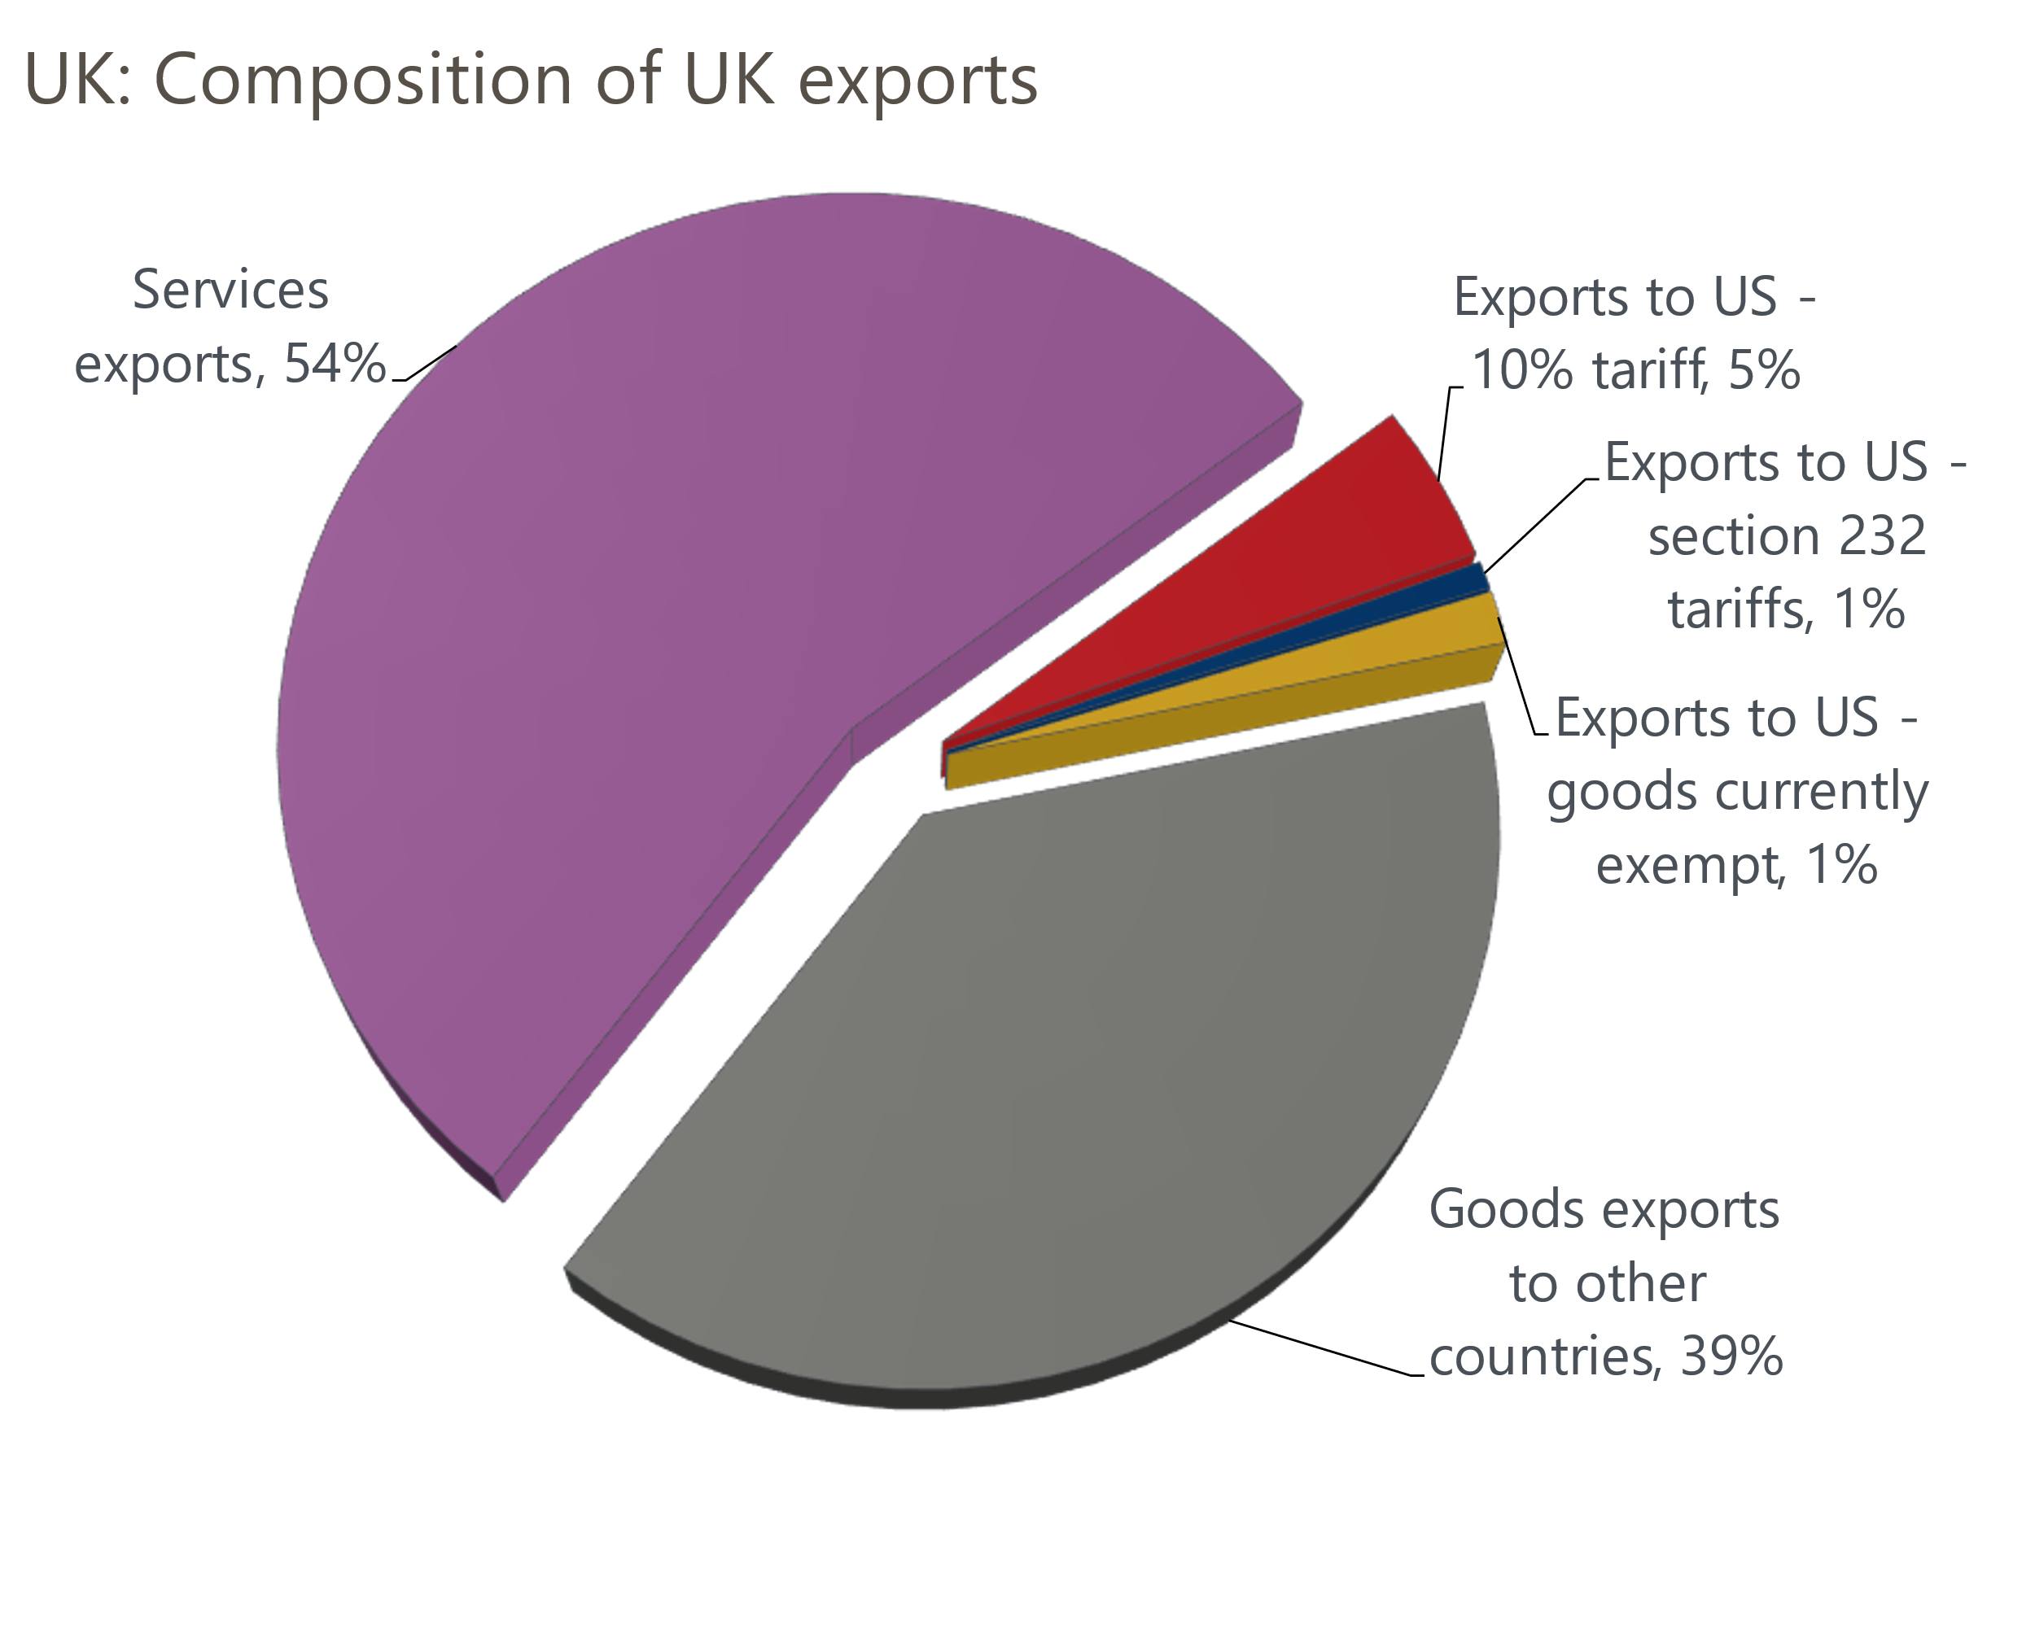
Source: Oxford Economics calculations using data from Haver Analytics
Second, we expect a large indirect impact via weaker demand from the US and rest of the world. US consumers face a sizeable real income shock, and we've cut our forecast for US GDP growth to 1.2% in 2025 from 2% last month and 1.6% in 2026 from 2.5%. Though the US is likely to suffer the biggest hit from its tariffs, the spillovers to the rest of the world will be significant, as reduced export revenues weaken domestic demand in other countries. We've cut our forecast for world GDP growth to 2.3% in both 2025 and 2026, down from 2.6% and 2.8% in March.
The cumulative impact of these two factors on UK export demand will be large. Historical data revisions mean our new forecast starts from a higher level than our March projection. But we still expect UK non-fuel goods exports at the end of 2026 to be more than 5% lower than we forecast in March.
Third, we expect the level of trade policy uncertainty to remain elevated for some time. Since President Donald Trump's 'liberation day' announcement on April 2, planned 'reciprocal' tariffs on trade partners apart from China have been suspended for 90 days. The increases have been temporarily held at 10%, whereas tariffs on China have been increased substantially. In addition, the US administration announced on April 11 that smartphones and a range of computing equipment had been exempted from reciprocal tariffs, although Trump subsequently stated that these goods would face new tariffs at some point.
Meanwhile, the US administration has signalled its willingness to negotiate trade agreements with partner countries. Given these negotiations could cover a wide variety of tariff and non-tariff barriers and many different countries, it will likely take some time for any talks to reach a conclusion. So it's clear that we will not reach a stable position for US trade policy for some time. Indeed, the experience of the past few weeks suggests the threat of sudden upward or downward spikes in tariff levels will linger for the duration of Trump's term in office and possibly even beyond.
Our previous research highlighted the impact of elevated trade policy uncertainty on growth prospects. For UK firms, this comes at a time when corporate profitability is at its lowest level as a share of GVA for more than 20 years, and businesses are having to navigate large increases in national insurance contributions and the national living wage. So we've cut our forecast for business investment further, and now expect it to remain broadly flat over the next couple of years (Chart 3).
Chart 3: Rising trade policy uncertainty has made us more bearish about business investment
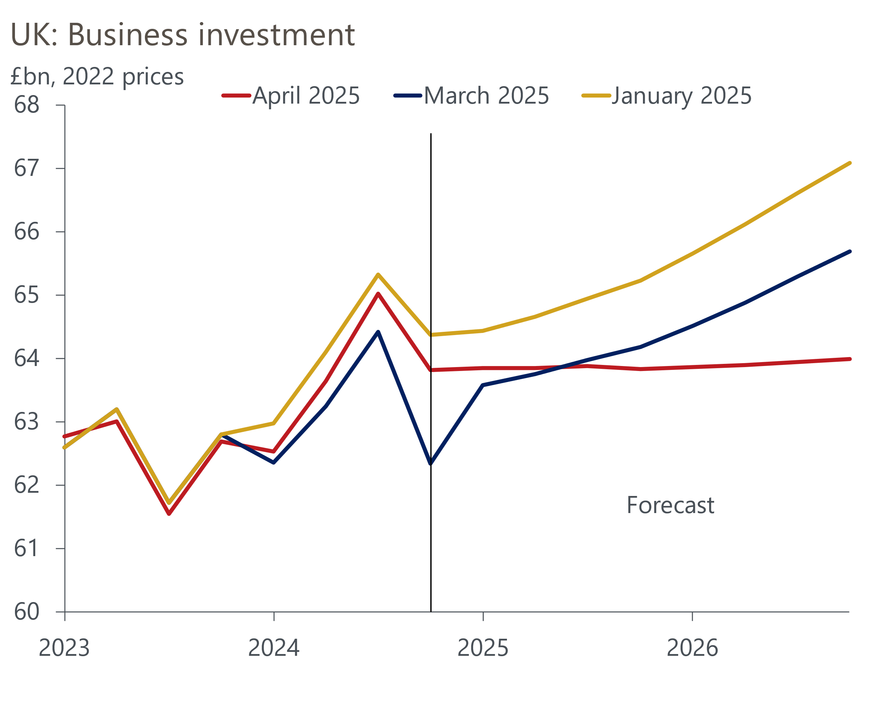
Sources: Oxford Economics, Haver Analytics

We've cut our near-term inflation forecast, but the risks are now greater
Given the UK government has opted not to retaliate with higher tariffs of its own, the changes to our inflation forecast are much smaller than the revisions to our growth projections. We now forecast that CPI inflation will average 3% in 2025 and 2.4% in 2026, down from 3.2% and 2.6% last month (Chart 4).
Chart 4: We expect inflation will be slightly lower over the next couple of years
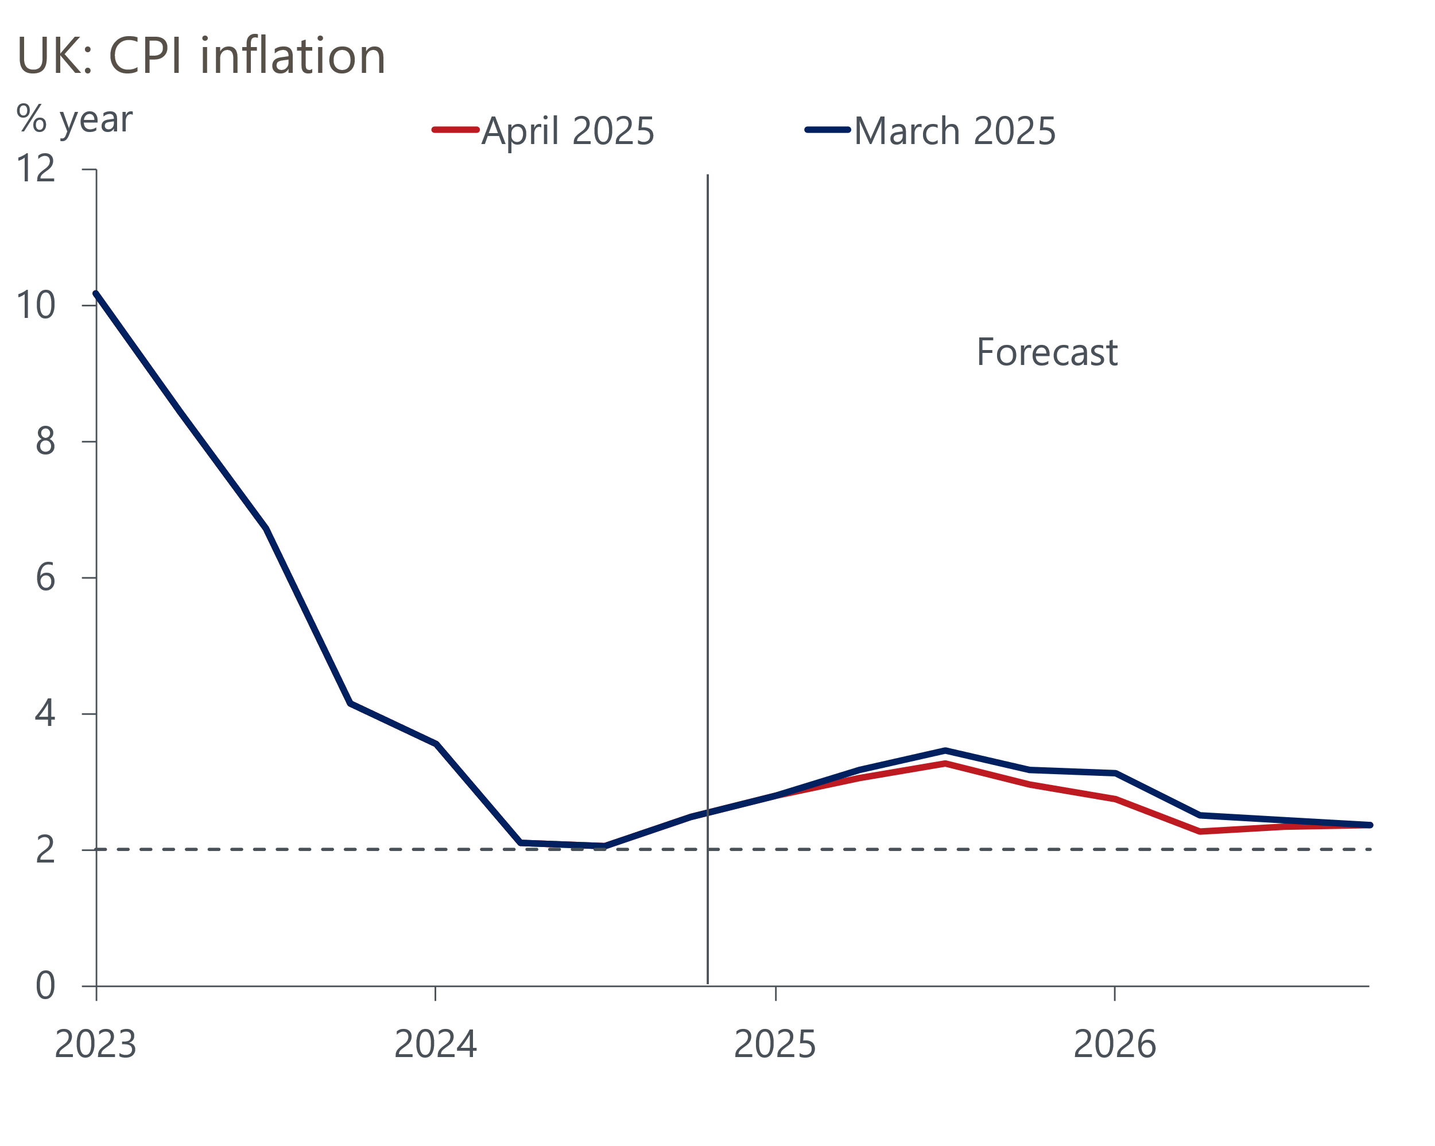
Sources: Oxford Economics, Haver Analytics
The main factor behind changes to our inflation forecast has been the financial market response to the April 2 announcements. The dollar has weakened against most currencies, including sterling, while oil and to a lesser extent European gas prices have fallen. We expect the bulk of these shifts to hold in the near-term, leading us to nudge down our forecasts for UK petrol and domestic energy prices.
Though we've cut our forecast for GDP growth significantly, the simultaneous hit to supply means that we expect only modest downward pressure on core inflation from growing spare capacity. However, while the revisions to our baseline inflation forecast have been modest, the risks around that forecast have increased.
Two factors in particular could have offsetting impacts on the inflation outlook. The price of some imported goods could fall as producers from other countries seek markets to sell their goods that would otherwise have gone to the US. Given the scale of the US tariff increases, China will be an obvious source for many of these goods, and China's motivation to engage in this activity will partly depend on how successful it is at avoiding extreme tariffs by rerouting its products via other markets to the US. Recent media reports suggest that online retailers could be a popular channel to funnel cheap imports into the UK.
By contrast, US tariff increases threaten to disrupt supply chains and increase import costs. Modern supply chains typically involve components being produced in multiple different countries before being assembled. As the pandemic showed, disrupting these complicated supply chains can trigger product shortages and cause prices to surge.
Our baseline forecast assumes that the 10% across-the-board tariff increase remains in place, in which case the need to rearrange supply chains will be more limited. But if the threat of large and varying reciprocal tariffs returns, this could trigger a more fundamental reorganisation of supply chains, particularly in Asia.

No change to our Bank of England forecast: three more 25bps cuts in 2025
We've left our baseline forecast for Bank Rate unchanged, with three more 25bps cuts this year taking Bank Rate to 3.75% at the end of the year. Markets have recently repriced and are now in-line with our forecast (Chart 5).
Chart 5: Market pricing now implies three more 25bps rate cuts in 2025, the same as our forecast
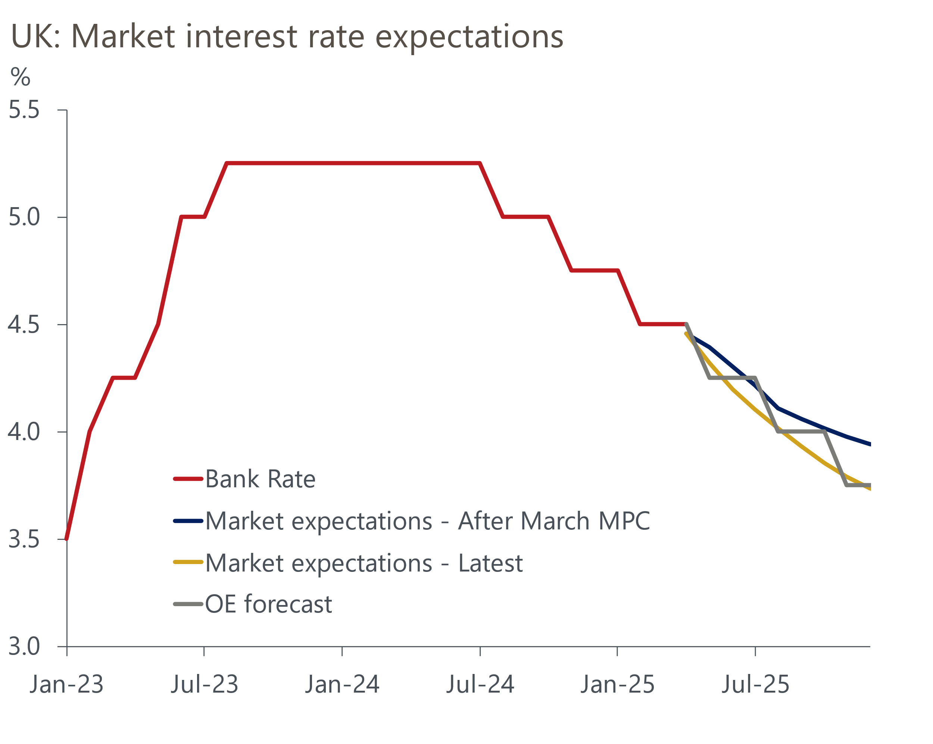
Sources: Oxford Economics, Haver Analytics
Bank Rate is still well above the level that the BoE considers to be neutral, suggesting there's still plenty of scope to cut rates further. And with the outlook for demand softening in response to US tariff announcements, the case for loosening monetary policy more quickly than we previously anticipated is strong.
But the Monetary Policy Committee has adopted a very cautious approach to loosening policy so far, reflecting its uncertainty around the strength of underlying inflationary pressures, and, since the February meeting, its related concerns about the persistent weakness of supply. While the case for adopting a more activist approach is strong, the MPC would need to overlook those supply concerns to make it happen.
We're sceptical that the MPC will do this. While the box on the impact of potential tariff increases in February's Monetary Policy Report was non-committal on the inflationary implications and likely policy response, it identified the potential for supply chain disruption. And the experience of 2023, when supply weakness and elevated inflation expectations combined to cause inflation to persistently surprise on the upside, is relatively fresh in the minds of MPC members.
The recent willingness of MPC members to comment on the growth implications of the US announcements, but not the impact on inflation, also points to continued caution. That pay growth, seen by the MPC as a key indicator of underlying price pressures, remains very strong will also be problematic for some committee members.

